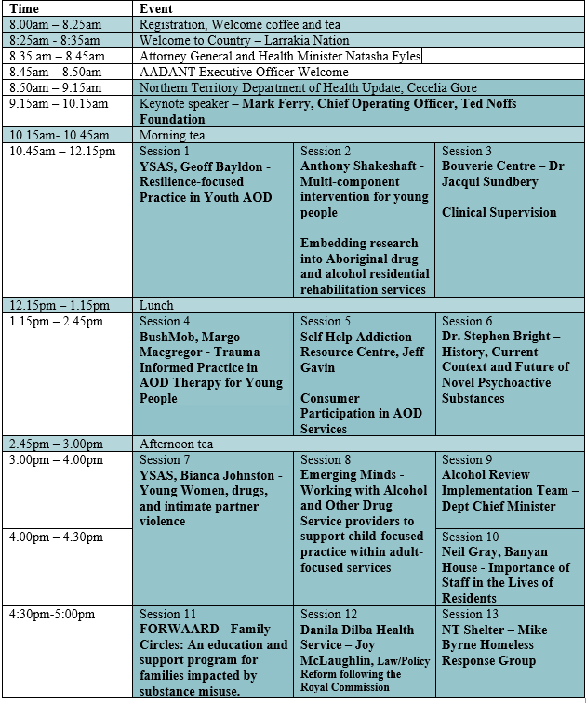
Program Day One: Wednesday 10th April 2019

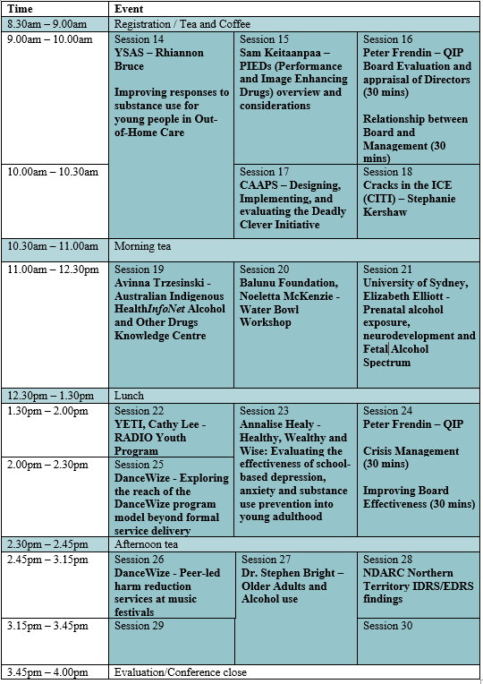
Program Day Two: Thursday 11th April 2019

