Feedback to the Department of Attorney-General and Justice, Liquor Commission re: Code of Practice for Responsible Promotion and Advertising of Liquor

Prepared by Richard Michell and Katie Flynn of the Association of Alcohol and other Drug Agencies NT
October 2018

Introduction
The Association of Alcohol and other Drug Agencies NT (AADANT) is the peak body for non-government organisation (NGO) Alcohol and Other Drug (AOD) treatment services across the Northern Territory. AADANT provides advocacy and representation to the NGO AOD sector in order to build capacity and support the sector’s needs.
AADANT would like to thank the Liquor Commission for inviting feedback on this document.

Definitions
AADANT – Association of Alcohol and other Drug Agencies NT
ABAC – Alcohol Beverages Advertising Code
AOD – Alcohol and Other Drug
CRTC - Canadian Radio-Telecommunications Commission
DoH – Department of Health
NGO – Non-government Organisation
NT – Northern Territory
NTG – Northern Territory Government
PALIs - Police Auxiliary Liquor Inspectors
RSA – Responsible Service of Alcohol
VCGLR – Victorian Commission for Gambling and Liquor Regulation
Table of Contents
International and Australian Codes for Alcohol Marketing and Advertising
Responsible Service of Alcohol Victorian Guidelines
Liquor venues - Licence, Liquor and RSA Inspectors
References

International and Australian Codes for Alcohol Marketing and Advertising
Level of alcohol marketing restrictiveness by country in 2008 shows Australia sits with six other countries and has “slightly restrictive” policies concerning alcohol marketing. There are 16 “restrictive” countries including Canada and the United Kingdom.
The document Focus On: Alcohol Marketing from Public Health Ontario in Canada highlights best practice in alcohol marketing policy, the impact of alcohol marketing on different populations, and identifies knowledge gaps. For the purpose of this feedback, this document explains young people are at greater exposure to alcohol marketing than adults per capita due to web-based marketing and ineffective age checks. Alcohol pricing “…influences purchasing and consumption behaviours, especially among high-risk drinkers whose current drinking pattern is harmful or puts them at increased risk for future harm.”
The Canadian Radio-Telecommunications Commission (CRTC) lists six key themes of the CRTC alcohol advertising code which include:
- Advertising must not encourage the general consumption of alcohol
- Advertising must not promote the irresponsible or illegal use of alcohol
- Advertising must not associate alcohol with social or personal achievement
- Advertising must not be directed to persons under the legal drinking age
- Advertising must not associate alcohol with the use of motor vehicles or with activities requiring a significant degree of skill or care
- Contestants and promotions cannot be conditional on the purchase or consumption of alcohol.
The document also states, “While the World Health Organisation (WHO) calls for an alcohol advertising ban, the strongest, more feasible model for regulating alcohol marketing is likely to be one in which government establishes and updates regulatory systems to reduce alcohol marketing exposure and monitor all forms of marketing.”
Alcohol marketing regulatory framework should provide a legislative basis to regulate:
- Marketing content – factual information protecting consumers against misleading information, protecting young people from attractive advertising, requiring standardised statements on the impact of alcohol on health.
- Volume of marketing – restricting quantity and location of ads, restricting time of day advertisements, banning ads near schools, on public transport, treatment centres, hospitals, or places of worship.
- Types of marketing – regulations should be flexible to address new and emerging forms of media

The WHO Global Alcohol Strategy marketing recommendations was endorsed by 193 Member States of the WHO identified marketing as an important policy area requiring national action. The recommendations of the strategy are below:
Area 6. Marketing of alcoholic beverages
Reducing the impact of marketing, particularly on young people and adolescents, is an important consideration in reducing harmful use of alcohol. Alcohol is marketed through increasingly sophisticated advertising and promotion techniques, including linking alcohol brands to sports and cultural activities, sponsorships and product placements, and new marketing techniques such as e-mails, SMS and podcasting, social media and other communication techniques. The transmission of alcohol marketing messages across national borders and jurisdictions on channels such as satellite television and the Internet, and sponsorship of sports and cultural events is emerging as a serious concern in some countries.
It is very difficult to target young adult consumers without exposing cohorts of adolescents under the legal age to the same marketing. The exposure of children and young people to appealing marketing is of particular concern, as is the targeting of new markets in developing and low- and middle-income countries with a current low prevalence of alcohol consumption or high abstinence rates. Both the content of alcohol marketing and the amount of exposure of young people to that marketing are crucial issues. A precautionary approach to protecting young people against these marketing techniques should be considered.
For this area policy options and interventions include:
(a) Setting up regulatory or co-regulatory frameworks, preferably with a legislative basis, and supported when appropriate by self-regulatory measures, for alcohol marketing by:
Regulating the content and the volume of marketing;
Regulating direct or indirect marketing in certain or all media;
Regulating sponsorship activities that promote alcoholic beverages;
Restricting or banning promotions in connection with activities targeting young people;
Regulating new forms of alcohol marketing techniques, for instance social media;
(b) Development by public agencies or independent bodies of effective systems of surveillance of marketing of alcohol products;
(c) Setting up effective administrative and deterrence systems for infringements on marketing restrictions.
Young people must not be targeted by alcohol advertising mentioned in all policies on marketing. Section 6.1 Principle 1: Promotions/Advertising must not appeal to young people “identifies young people as a priority group to consider in relation to alcohol harm minimisation as the young brain is more susceptible to permanent damage from alcohol.” 6.1.2 explains unacceptable practices (point 3) portraying alcohol in the context of, or in relation to, an activity that is attractive primarily to young people; and (point 4) using role models or celebrities that are generally linked to young people.
There appear to be issues with regulating these unacceptable practices in reality. Young people ages 0-25 can be present in numerous spaces and those 18+ can enter venues and purchase alcohol legally. While advertising should not target young people, prohibiting the advertisement of alcohol to young people by the definition including 18-25 means late night venues, cafes, sporting clubs, and entertainment centres cannot advertise alcohol under the draft code of practice. For the purpose of the code of practice, the definition of a young person should be anyone under the legal drinking age as limiting advertising to the group 18-25 years would be removing advertising in nearly all venues with liquor licenses.
While AADANT supports restricting advertising of alcohol to young people, practicing this code may be harder than first thought. The use of celebrities and role models could be difficult to enforce. For example, Matt Wright is popular with young children and has a National Geographic television show. He may be considered a role model/celebrity and also has a sponsorship with Great Northern Beer. Nick Cummins, who represented Australia playing Rugby for the Wallabies, has a sponsorship with Iron Jack Beer. The same can be said about multiple professional athletes who play with alcohol logos on their uniforms and/or on signage around the field/court/stadium.
Responsible Service of Alcohol Victorian Guidelines
Victoria is the only state in Australia requiring face-to-face training for a Responsible Service of Alcohol (RSA) certification. If you hold a RSA from another state or territory, you are required to take a bridging course to transfer your RSA to meet Victorian guidelines. A refresher course is required every three years for licensees and staff. The Victorian Commission for Gambling and Liquor Regulation (VCGLA) published Responsible Liquor Advertising and Promotions (Figure 1) in 2012 which match most of what the Liquor Commission has proposed in the draft Code of Practice for Responsible Promotion and Advertising of Liquor.
The Northern Territory should consider increased compliance measures (such as face-to-face) around the completion of an RSA especially with new legislation requiring floor price for alcohol. Without an understanding of what a standard drink is considering volume and percentage of alcohol - which is taught in the RSA course - floor price may not be adhered to.
From section 7 of the draft, “…licensees will need to ensure that any advertisements, promotions or offers that include the provision of liquor products does not offend the legislation.”
Licensees will need to be briefed on the appropriate use of complimentary drinks in relation to floor price, and appropriate specials for drinks which abide by floor price legislation. An example of a popular violation of floor price would be the “Ladies Night” promotion in Darwin on Mitchell Street that offers free entry to women before 11pm and offers a complimentary glass of champagne on entry. These licensees may not realise floor price will prohibit this promotion (7.1), and there may be confusion around what drinks are acceptable for complimentary offers.
With new legislation introduced, it is important to ensure the RSA certification mentions this and adequately explains how to responsibly serve alcohol under floor price legislation.

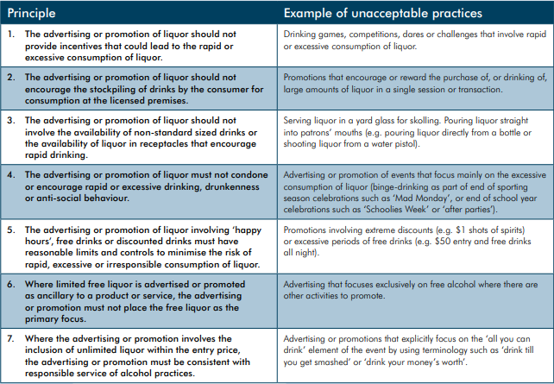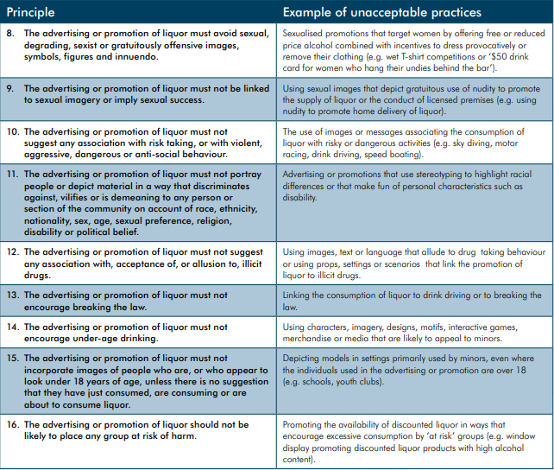
(Figure 1: VCGLR Responsible liquor advertising and promotions)

Liquor venues - Licence, Liquor and RSA Inspectors
The introduction of Police Auxiliary Liquor Inspectors (PALIs) to the Northern Territory has a primary focus on the purchase of takeaway alcohol at bottle shops and a small team dedicated to targeting secondary supply. With these new officers, Police are relieved from the duties the PALIs are now taking over. The PALIs may be able to turn away patrons from purchasing takeaway at certain outlets, but pubs and clubs can still operate without PALIs at their door, some of which offer takeaway alcohol for purchase.
October 1st marked the introduction of floor price in the Northern Territory. With new regulations in place, there will be more for liquor and licensing inspectors to consider including but not limited to (in this draft code of practice):
- Complimentary drinks
- Signage advertising drink specials/ floor price considerations for drink specials
- Advertisement involving young people under the legal drinking age (e.g., sporting events, sponsors for all-ages events, signage on a-frames and posters in social clubs, family-friendly taverns and pubs, etc.)
AADANT questions the availability of liquor/licensing inspectors to be able to cover the necessary ground required to adequately and effectively ensure the safe and responsible service and advertisement of alcohol to patrons including takeaway.
The Northern Territory has 677 active and registered liquor licenses as of October 5, 2018.
- 57 active licenses in Darwin CBD (0800)
- 207 active licenses in surrounding Darwin Suburbs (0820, 0812, 0810, 0811, 0801)
- 40 active licenses in Palmerston (0830, 0832, 0835)
- 19 active licenses in Katherine (0850)
- 6 active licenses in Tennant Creek (0860)
- 41 active licenses in Alice Springs (0870)
- 25* active licenses in Yulara (0872)
* Not including those via Alice Springs
These figures account for 395 of 677 venues easily accessible though spread throughout the Territory. AADANT is conscious there may not be enough liquor/licensing inspectors to adequately cover the entire area and ensure quality service, advertisement and adherence to the proposed draft code of conduct.
Of the 677 licensed premises, all employees must obtain an RSA including the licensee. Ensuring the standard of this practice is followed through within 30 days of employment could prove difficult but needs to be mandatory to understand the floor price legislation against standard drinks.

References:
Government, Northern Territory. “Floor Price.” Alcohol Policies & Legislation Reform, Northern Territory Government, 24 Aug. 2018, alcoholreform.nt.gov.au/floor-price.
Government, Northern Territory. “List of NT Licensed Premises.” Chemical Control - NT.GOV.AU, Https://Nt.gov.au, 30 May 2018, nt.gov.au/industry/hospitality/list-of-nt-licensed-premises.
“Liquor Licensing Fact Sheet Responsible Liquor Advertising & Promotions.” The Victorian Commission for Gambling and Liquor Regulation (VCGLR), Feb. 2012, www.vcglr.vic.gov.au/sites/default/files/uploadLiquor_licensing_fact_sheet_-_Responsible_liquor_advertising___promotions_1.pdf.
Ontario Agency for Health Protection and Promotion (Public Health Ontario), Giesbrecht N, Wettlaufer A Focus On: Alcohol marketing. Toronto, ON: Queen’s Printer for Ontario; 2016.
“Policies to Regulate Alcohol Marketing - IAS.” Institute of Alcohol Studies, 2017, www.ias.org.uk/Alcohol-knowledge-centre/Marketing/Factsheets/Policies-to-regulate-alcohol-marketing.aspx.
“Responsible Service of Alcohol (RSA).” Victorian Commission for Gambling and Liquor Regulation, 29 May 2017, www.vcglr.vic.gov.au/liquor/restaurant-cafe/education-and-training/responsible-service-alcohol.
“Tackling Alcohol Fuelled Crime: Police Auxiliary Liquor Inspectors Sworn In.” Northern Territory Government Newsroom, NTG, 31 May 2018, newsroom.nt.gov.au/mediaRelease/25702.

